C0566 - Doc Man Object Transformation (ManSuppInvoice to PO link)

|  |  |  |  |  |
| --- | --- | --- | --- | --- |
| **Ver** | **Date** | **Author** | **Comments** | **Reviewed by** |
| 1 | 05/03/2021 | Tom Bell | CRIM 0566 | TBC |
|  |  |  |  |  |

Requirements 2

Prerequisites 2

Solution Overview 2

Solution Details 2

Security 3

Companies 3

Data Migration 3

Test Steps 3

Technical Implementation 3

Requirements

Require an Object Transformation between Purchase Order and Manual Supplier Invoice screens for Doc Man.

Attachments on the Manual Supplier Invoice screen, need to auto attach on the Purchase Order screen for the Purchase Order that is linked to the Manual Supplier Invoice.

Solution Overview

**Manual Supplier Invoice Screen**

* **Logical Unit** = Manual Supplier invoice
* **Primary Key** = Invoice_ID
* **Referencing Field (Foreign Key)** = PO_REF_NUMBER **(*LINK HERE*)**

**Purchase Order Screen**

* **Logical Unit =** PurchaseOrder
* **Primary Key** = ORDER_NO **(*LINK HERE*)**

The below screenshot shows the Object Transformation that is required to take place. Here the Purchase Order is the Target and the ManSuppInvoice is the Source.

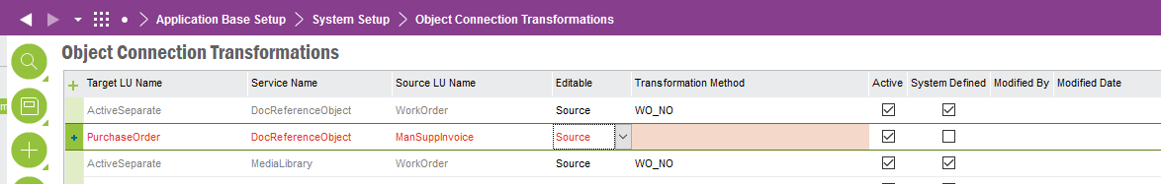

**The below screenshot shows the Object Transformation Method. Currently, the system cannot link the Invoice_ID from the Source using the Purchase Order Ref as the Target LU Key. We need these two screens linking together using the PO Ref number field, not the Invoice ID.**

(I think the tables need to be linked using the PO_Ref from the ManSuppInvoice foreign key).

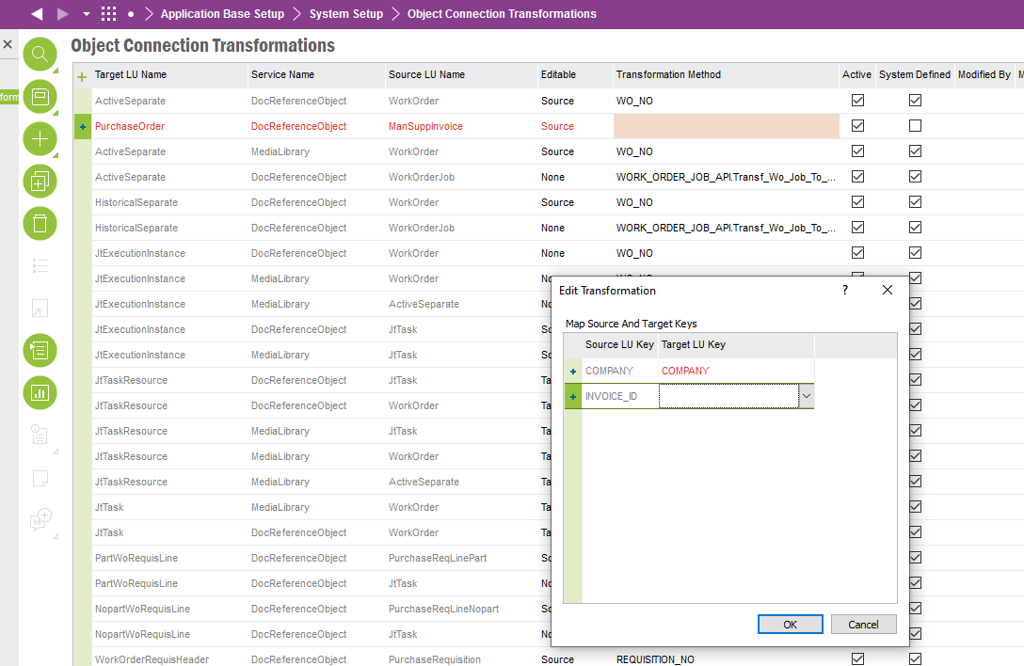

The below screenshot shows the PO Ref field on the Manual Supplier Invoice screen. The screen to the right shows the Purchase Order Number ID.

These two screens must be linked on the Object Transformation screen using these keys. It is currently not possible to do this in out of box Object Transformations.

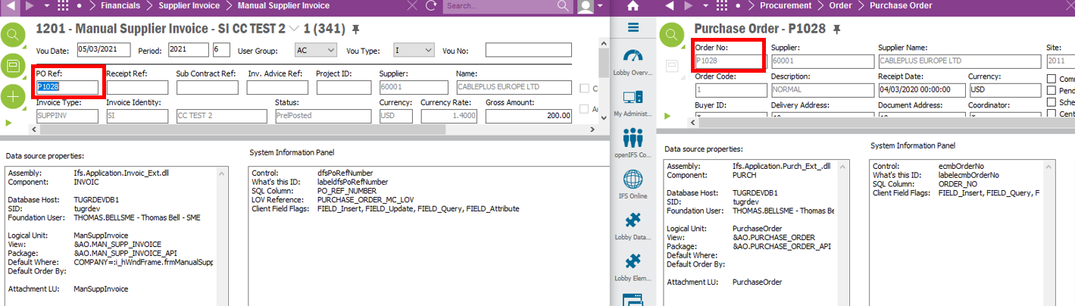

**Technical.**

Field Definitions.

<New Field/CLU Definition>

|  |  |  |  |  |  |  |
| --- | --- | --- | --- | --- | --- | --- |
| New DB Object Name | DB Object Item/Field Names | Item Description | Item Data Type | Item Syntax | Calculation Spec, if Derived | LOVs/Enums/Is Mandatory? |
|  |  |  |  |  |  |  |
|  |  |  |  |  |  |  |
|  |  |  |  |  |  |  |
|  |  |  |  |  |  |  |
|  |  |  |  |  |  |  |
|  |  |  |  |  |  |  |
|  |  |  |  |  |  |  |
|  |  |  |  |  |  |  |
|  |  |  |  |  |  |  |
|  |  |  |  |  |  |  |
|  |  |  |  |  |  |  |
|  |  |  |  |  |  |  |

Security

<Define security controls> (Who needs access to this and will it be restricted from any other users etc)

Companies

Applies to the following companies. All.

|  |  |
| --- | --- |
| **Company** | **Required (Y/N)** |
| 1201 | Y |
| TBC |  |
|  |  |

Data Migration

<Describe any data migration impacts this development may have – i.e additional data to be migrated>

Test Steps

<Steps that needs to be taken to test this change. Please provide expected results> Updated post solution.

|  |  |  |
| --- | --- | --- |
| **No** | **Script\Test Steps** | **Expected Result** |
| 1 | Add an attachment to the Manual Supplier Invoice screen. | Open up the linked PO and see the same attachments. |
| 2 |  |  |
| 3 |  |  |
| 4 |  |  |
|  |  |  |
|  |  |  |

Technical Implementation

<Completed by the technical developer - Technical solution, list packages, functions, Custom menus created etc >

**Package**

N/A

**Permission Granted**

IFS_ALL

**Object Connection Transformation**

Add this record shown below manually in the Object Connection Transformation Window.

**Util Package Code**

C_EA_Customization_Util_API.Transf_Mansup_Attach_To_PO